Guiding Behavior
Guiding Behavior
Teaching Self Discipline
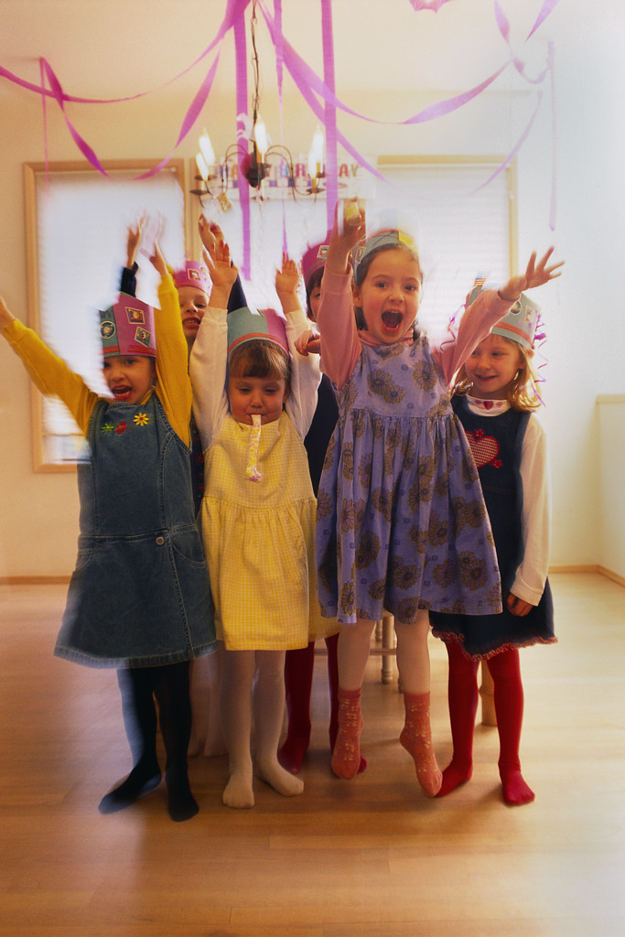

Teaching Character to Preschoolers
Different character qualities can be emphasized at different developmental stages. A newborn, for example, learns about love, trust, and a positive view of the world because of the loving care given by parents. As children grow and develop, new character qualities are added to the picture. Preschoolers are at a strategic age to learn so much about life. Creativity, compassion, patience, confidence, and cooperation are just a few of the many new qualities that begin to develop during these years.
Two character qualities, in particular, become a focus in the parent/child relationship: Self-discipline and responsiveness to authority. But please don't think that teaching these qualities requires harshness, demandingness, or an authoritarian approach. Rather, these qualities can be taught with a loving firmness that prepares children for greater success in life.
Preschoolers learn self-discipline skills by coming when called instead of running away. These children also learn about a bedtime and how to hold a parent's hand in a store or out in public. Children resist these attempts to help them learn to give up their agenda, but that's what self-discipline is all about. Even adults resist a diet, staying on a budget, or an exercise program. If we can teach children self-discipline when they're preschoolers, they'll begin to develop significant tools for when they get older.
Talk about self-discipline with preschoolers. They may not understand the term yet, but they'll grow into it. We can teach self-discipline through a number of family rules. When we go into a store, we have the "No Touch Rule." When in a library or bank, we may use the "Don't be Wild Rule." When you first teach rules like these, start by making them fun. Teach the rules like a game, then put them into practice in life and enforce the new rules with repetition and practice.
"But my kids won't do these things," you may say. And maybe they won't unless you practice. But the preschool years are an excellent time to build some character qualities that will last a long time in a child's life.
This idea was taken from the CD series, "Parenting Toddlers, Establishing Healthy Patterns from the Start," by Dr. Scott Turansky and Joanne Miller, RN, BSN.


